**ASSIGNMENT 1**

**CSCI 5930 – Homework 1: Statistical values**

**Name:** Sowmya Mutya

**Banner ID:** 001303248

**1- Find the mean and standard deviation of A.**

**A = {9,10,11,7,13, 7,4,11,13,10}**

**Mean:**

Mean or average is calculated as sum of all values divided by total number of values.

Mean= Sum of values

Total number of values

Mean=(9+10+11+7+13+7+4+11+13+10)

10

Mean=95

10

Mean=9.5

**Standard deviation:**

The standard deviation is a measure of the amount of variation or dispersion from the mean in a set of values.

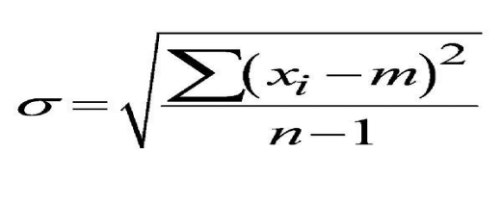

Where σ is standard deviation

m is mean

n is the total number of values in the data

Standard deviation is calculated the following way:

Step1: Calculating mean

Mean=(9+10+11+7+13+7+4+11+13+10)

10

Step2: finding deviation from the mean for every value of the data A

(9 - 9.5) = -0.5

(10 - 9.5) = 0.5

(11 - 9.5) = 1.5

(7 - 9.5) = -2.5

(13 - 9.5) = 3.5

(7 - 9.5) = -2.5

(4 - 9.5) = -5.5

(11 - 9.5) = 1.5

(13 - 9.5) = 3.5

(10 - 9.5) = 0.5

Step3: Square of each deviation from the mean

(-0.5)² = 0.25

(0.5)² = 0.25

(1.5)² = 2.25

(-2.5)² = 6.25

(3.5)² = 12.25

(-2.5)² = 6.25

(-5.5)² = 30.25

(1.5)² = 2.25

(3.5)² = 12.25

(0.5)² = 0.25

Step4: Calculating mean of individual standard deviations

= (0.25 + 0.25 + 2.25 + 6.25 + 12.25 + 6.25 + 30.25 + 2.25 + 12.25 + 0.25) 10-1

= 72.5

9

= 8.0555555556

Step5: Take square root of the mean of individual standard deviations

√7.25 =2.838231061

So, the standard deviation of the above data A ={9,10,11,7,13, 7,4,11,13,10} is approximately 2.84

**3- Write a code in Python:**

**a) Enter vector A of question 1 in Python. Copy the code. (Hint: A<- c(2,4,...))**

Creating a vector using a NumPy array:

Python code:

import numpy as np

A=[9,10,11,7,13,7,4,11,13,10]

vector=np.array(A)

print(vector)

Output:

[9,10,11,7,13,7,4,11,13,10]

The above python code converts the array to vector and prints the vector A of the above given data.

**b) Find the mean and standard deviation of A. Copy the code.**

As we considered standard deviation for a sample we consider it as sample standard deviation. If we have considered total population we would take sample_std = np.std(vector) instead of sample_std = np.std(vector, ddof=1)in the below python code.

Python code to calculate mean and standard deviation:

import numpy as np

# Defining the vector A

A=[9,10,11,7,13,7,4,11,13,10]

vector=np.array(A)

# Calculating the mean of the vector A

mean_A = np.mean(A)

# Calculating the standard deviation of the vector A

sample_std = np.std(vector, ddof=1)

# Prints the mean and standard deviation

print("Mean:", mean_A)

print('Sample standard deviation: ', sample_std)

Output:

Mean: 9.5

Sample standard deviation: 2.8382310609877335

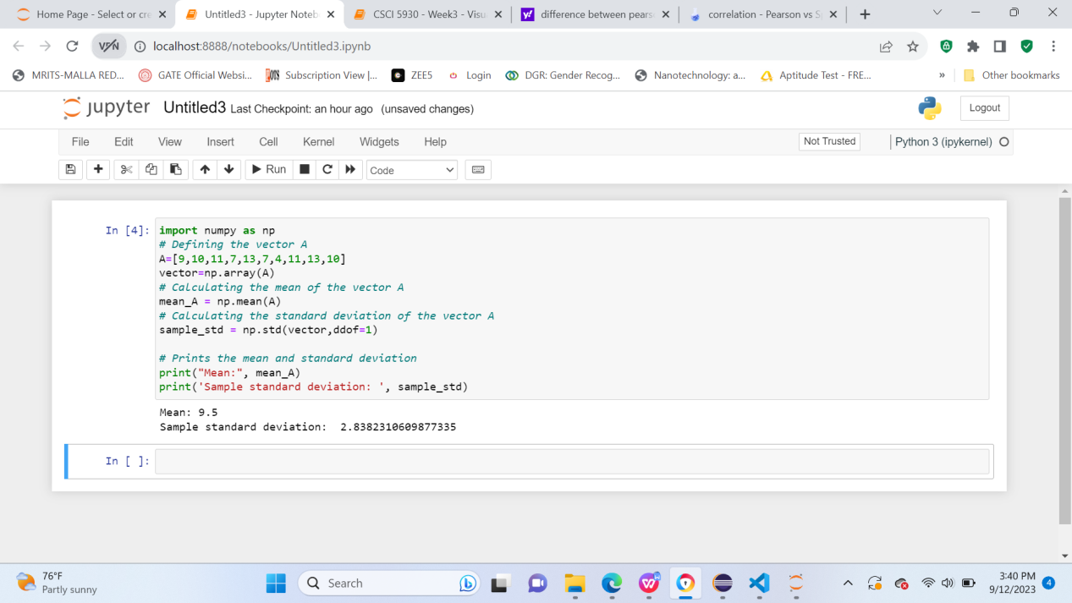

**c) Do your results match question 1?**

Yes, the results of the question 1 match with the result of above python code.